🧪 🚨 LAB: Error Handling with trap in Shell Scripting
This is a very useful Linux/DevOps scripting concept 🔥
You’ll learn:
✅ What trap does
✅ How to catch errors/signals
✅ Cleanup before script exits
✅ Real-world error handling

🧠 What is trap?
trap lets your script:
👉 “Catch” events like:
- Errors
- Ctrl + C
- Script exit
- Interruptions
Think:
Something went wrong ❌
→ Script reacts automatically ✅

⚙️ Step 1: Create script
nano traplab.sh

✍️ Step 2: Paste this script
#!/bin/bash

# Function for cleanup
cleanup() {
echo "🧹 Cleaning up before exit..."
}

# Trap EXIT signal
trap cleanup EXIT

echo "🚀 Script started"

# Create temp file
touch temp.txt

echo "📄 Temporary file created"

# Simulate work
sleep 5

echo "✅ Script completed"
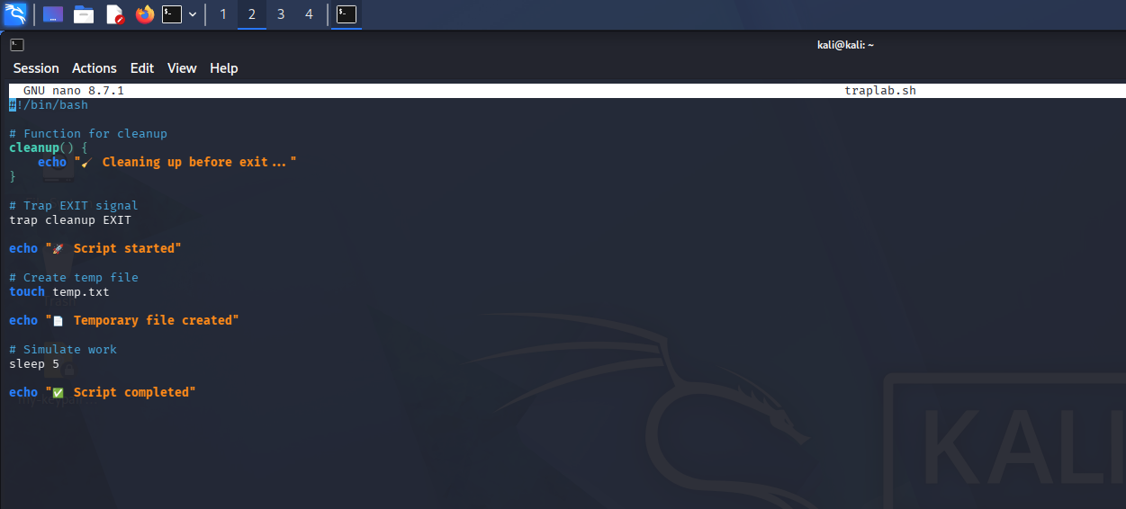

🔐 Step 3: Give permission
chmod +x traplab.sh

▶️ Step 4: Run script
./traplab.sh

🎯 Expected Output

🚀 Script started
📄 Temporary file created
✅ Script completed
🧹 Cleaning up before exit...
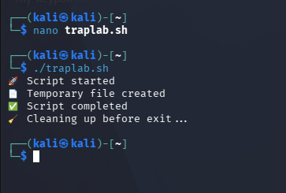

🧠 What happened?
This line:
trap cleanup EXIT
means:
👉 “When script exits, run cleanup function”

💥 Step 5: Catch Ctrl + C (IMPORTANT 🔥)
Edit script:
nano traplab.sh
Replace with:
#!/bin/bash

handle_interrupt() {
echo ""
echo "⚠️ Ctrl + C detected!"
echo "🛑 Script interrupted safely"
exit 1
}

# Catch Ctrl+C
trap handle_interrupt SIGINT

echo "🚀 Running script..."

while true
do
sleep 1
echo "⏳ Working..."
done
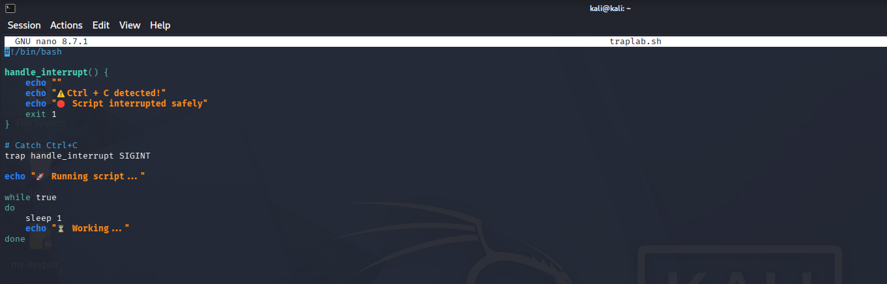

▶️ Run script
./traplab.sh
Now press:
CTRL + C

🎯 Expected Output
⚠️ Ctrl + C detected!
🛑 Script interrupted safely
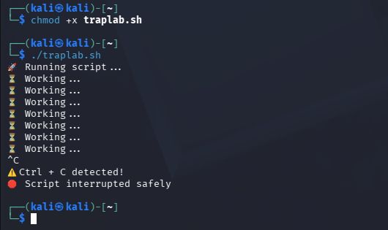

🚀 Real-world DevOps usage
trap is used for:
- Cleanup temporary files
- Graceful shutdown
- Logging errors
- Stopping processes safely
- Automation recovery

🔥 Step 6: Realistic cleanup example
#!/bin/bash

cleanup() {
rm -f temp.txt
echo "🧹 Temp file removed"
}

trap cleanup EXIT

touch temp.txt

echo "Working..."
👉 Even if script crashes:
✅ temp file gets removed

🧠 Important signals
Signal | Meaning
EXIT | Script exits
SIGINT | Ctrl+C
SIGTERM | Termination
ERR | Command failure

⚡ Bonus: Catch command errors
trap 'echo "❌ Error occurred!"' ERR

🎤 Interview-ready answer
“I use trap in shell scripting to catch signals and handle errors gracefully, such as cleaning temporary files or safely terminating scripts during failures.”

💡 Simple memory trick
trap = “If something happens → do this”

🚀 Mini Challenge
Modify script to:
✅ Create log file
✅ Remove log file on exit
✅ Catch Ctrl+C

